**SIMPLE TOPOLOGY FOR TESTING NETWORK AUTOMATION APPLIENCE**

Step 1:- Download GNS3 Network Automation appliance.

* Go to <https://www.gns3.com/marketplace/appliance/network-automation> or goolgle “ansible network automation in gns3” and download.
* Click and download. You will get one file in .gns3a extension

Step2:- Place the network devices and appliances.

* Click edit and Import appliance 🡪 Select the download file (Use all recommended/default options while importing.)
* Place it on workspace and create below topology.

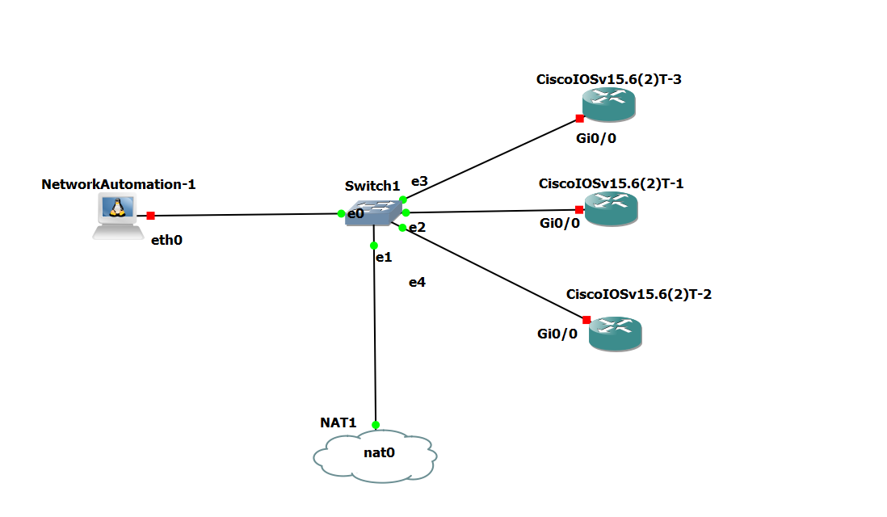

Step3:- Get topology working (Assigne IPs and configure SSH2 protocol.)

* Open console of “NetworkAutomation-1”
* Hit nano /etc/network/interfaces
* Uncomment last two lines and save exit. And restart the “NetworkAutomation-1”(By doing this you will get ip assigned directly via DHCP and you will be connected to internet)

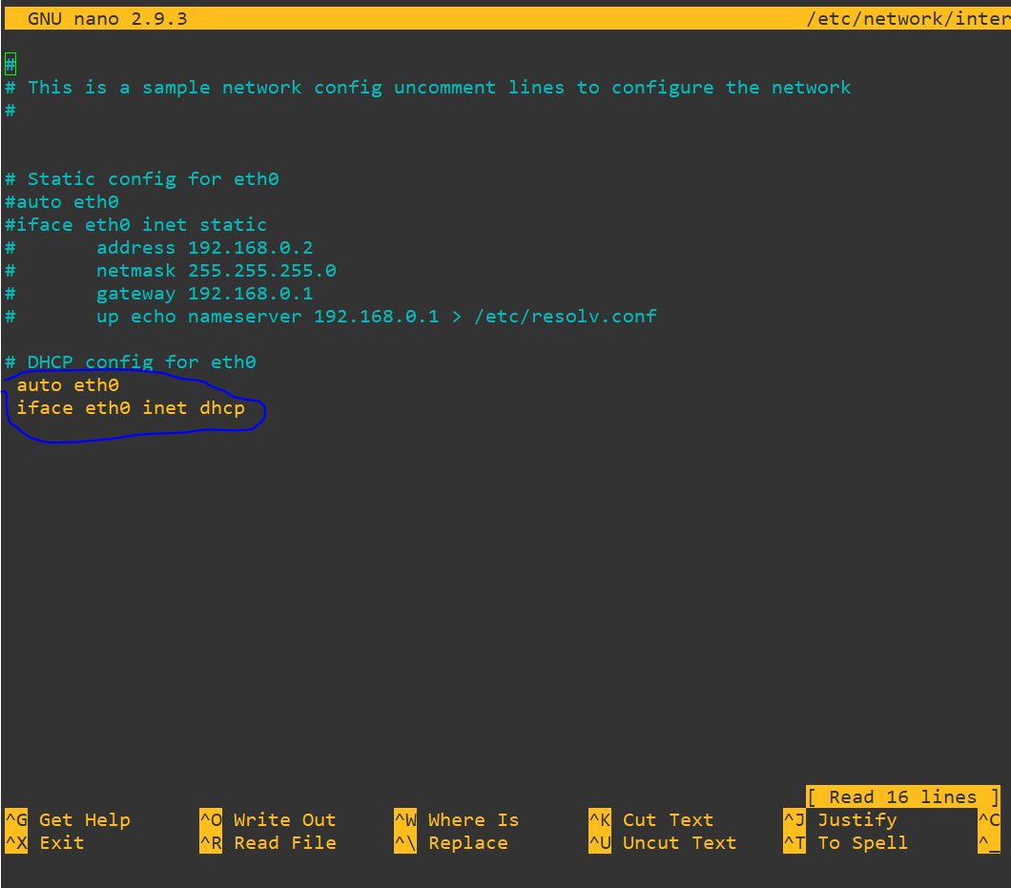

Step4:-Assigne IPs to network devices and configure SSH2

* Assign the static ip address to the network devices so that all the devices are in the same network. (Subnetmask /24). Make ping test.
* Once ping test is done. Configure SSH2 with the help of following commands.
  + - username <username> passw <simple password>
    - username <username> privi 15
    - line vty 0 4
    - transport input all
    - login local
    - exit
    - ip domain-name <anydomain>
    - crypto key gene rsa
      * select 1024byte of key.(Press Enter)

Now you should be able to ssh to the network devices from “networkAutomation-1”